**Take two servers, server A and server B**

**in server A: (development server)**

[] install jenkins (we face one issues in install suggested plugins in server right click on top where ip address click reset terminal)



[] su jenkins **--> switch root to jenkins**

[] pwd we need to get /var/lib/jenkins

[] cd then give pwd

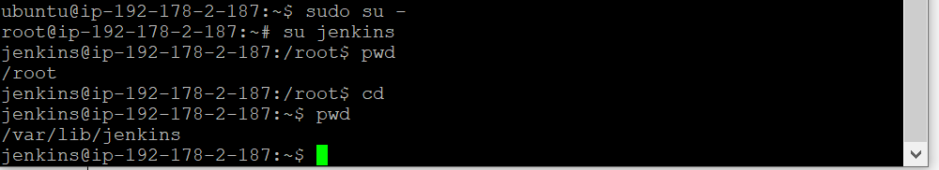

[] ssh-keygen –t rsa

[]enter

[] enter

[] ls **---> check .shh file**

[] cd .ssh

[] ls **----> we get two fle id_rsa.pub(public key) and id_rsa (privet key)**

[] cat id_rsa.pub **---> copy the public key**

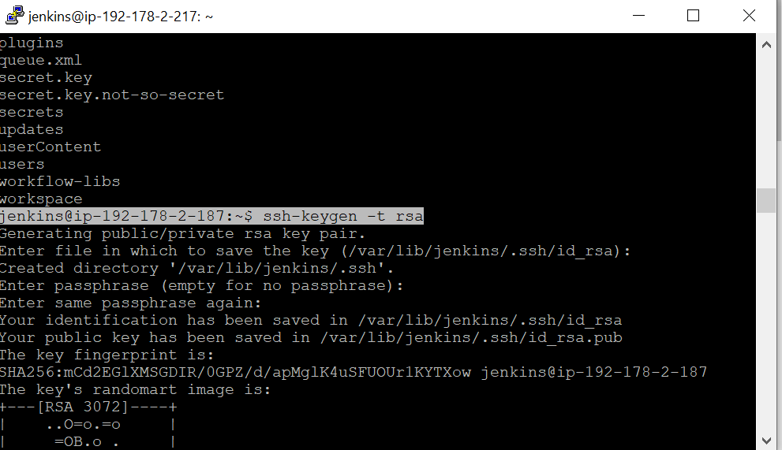

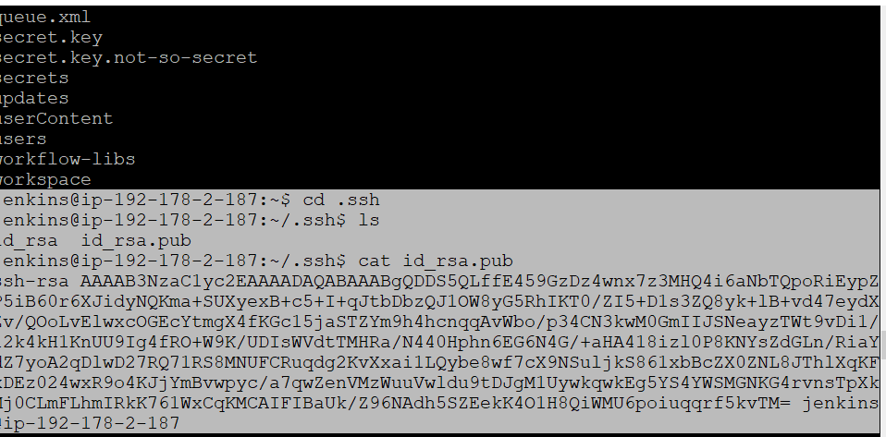

**In Server B:(production server)**

[] install java

[] useradd –m jenkins **----> create user**

root@ip-192-178-2-187:~# su jenkins

If in case we get [] $ if we get $ symbol give [] bash

jenkins@ip-192-178-2-187:**/root**$ pwd

/root

jenkins@ip-192-178-2-187:/root$ **cd --> come out file root**

jenkins@ip-192-178-2-187:~$ pwd

/home/jenkins **--->we need to get like**

[] ssh-keygen –t rsa

[] enter

[] enter

[] ls –a **----> check .ssh folder**

[] cd .ssh

[] ls ----> we get two fle id_rsa.pub(public key) and id_rsa (privet key)

[] rm id_rsa.pub id_rsa

[] vi authorized_keys **--------> past server A content of cat id_rsa.pub**

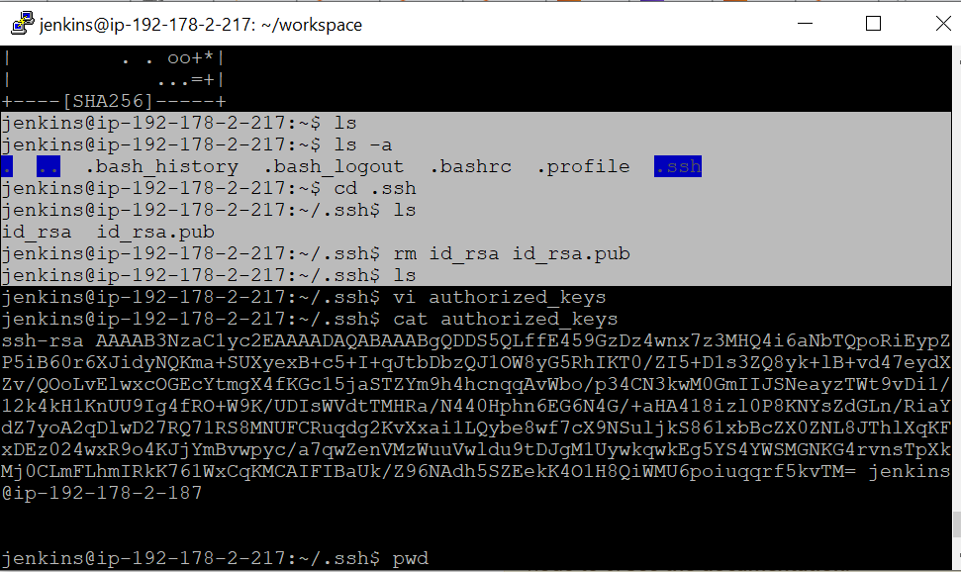

**in server A: (development server)**

[] ssh jenkins@serverB ip

[] give YES

[] now it connect to server B

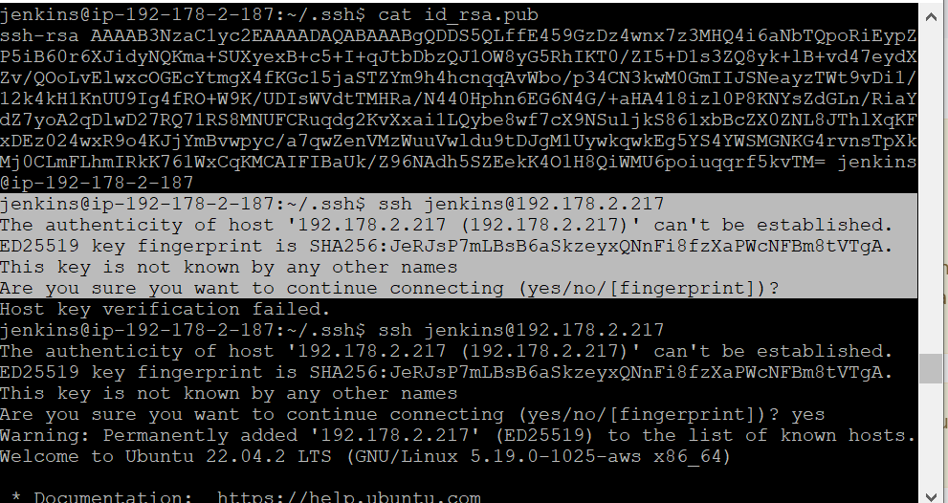

[] exit

[] exit **----> again switch to server A**

[] ls **---> know_host and know_host.old are created**

**In jenkins**

[] manage jenkins

[] nodes and clouds

[] new node

[]name **--->whatever it displays as server name**

[] remote root directory

/home/jenkins/ **------> what we created in server B like useradd** jenkins

[]label **---->whatever we mention this label name in pipeline**

[] usage

Select [] only build jobs with label expressions matching this node

[] launch method

Select [] launch agent via SSH

[] host

[] ip adders of production/server B

[] credentials

[] kind

Select [] SSH username with private key

[] ID

[] description

[] username

[] jenkins **----> we created in server B**

[] private key

Select [] enter directly

[] Add

[] Past content of [] cat id_rsa

[] save

[] check in log it shows successfully connected

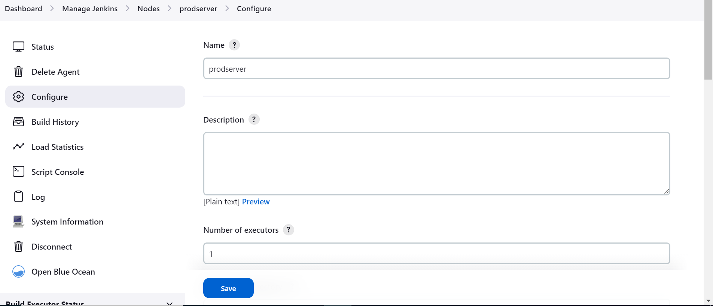

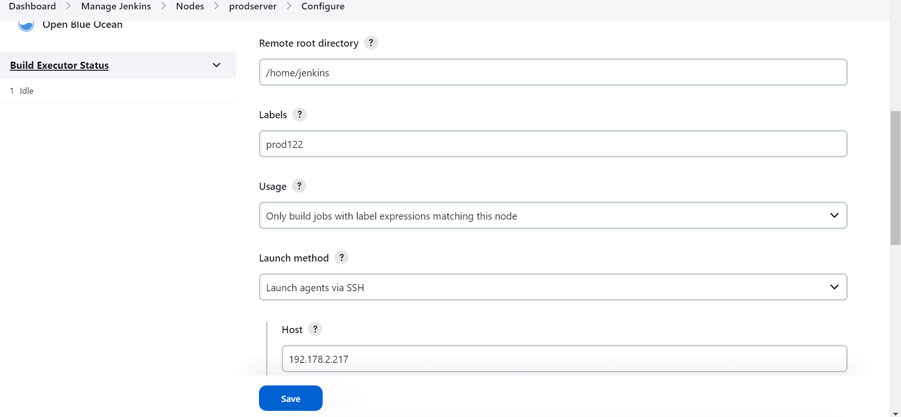

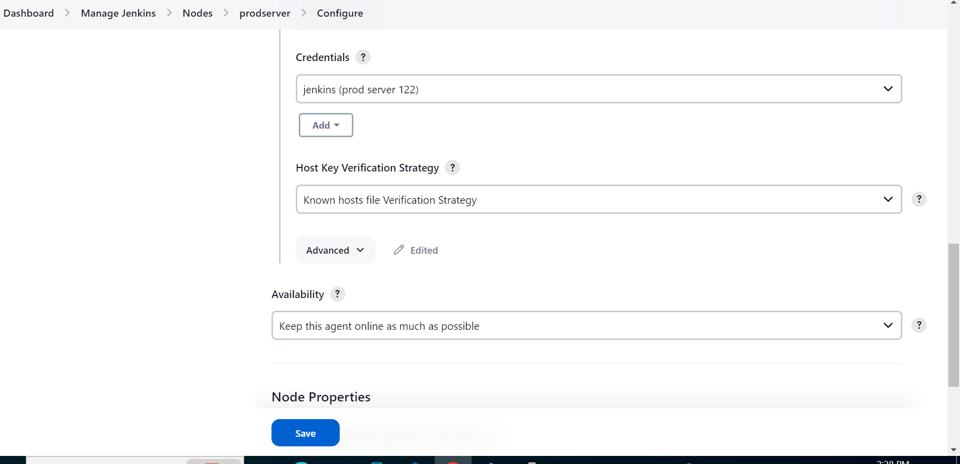

**In credential:**

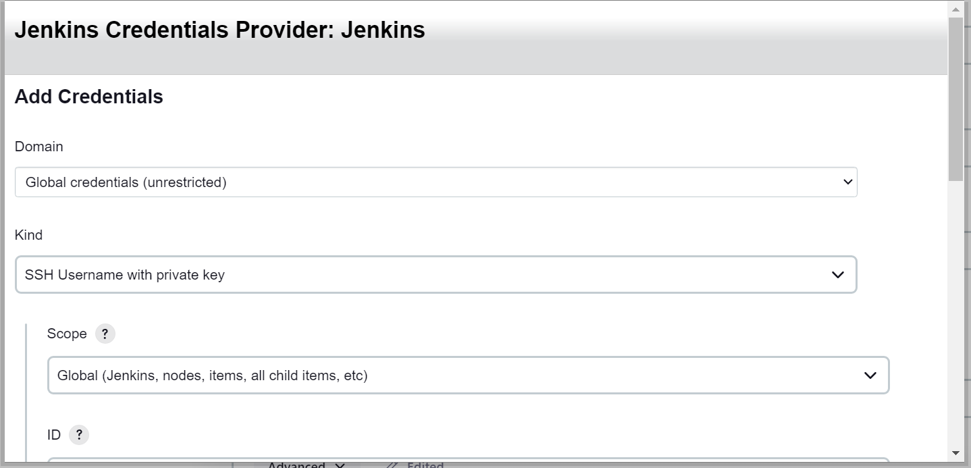

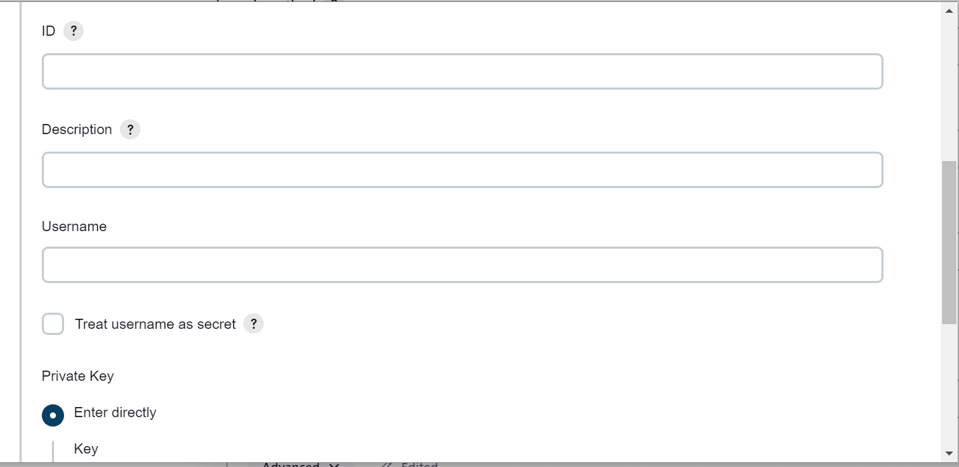

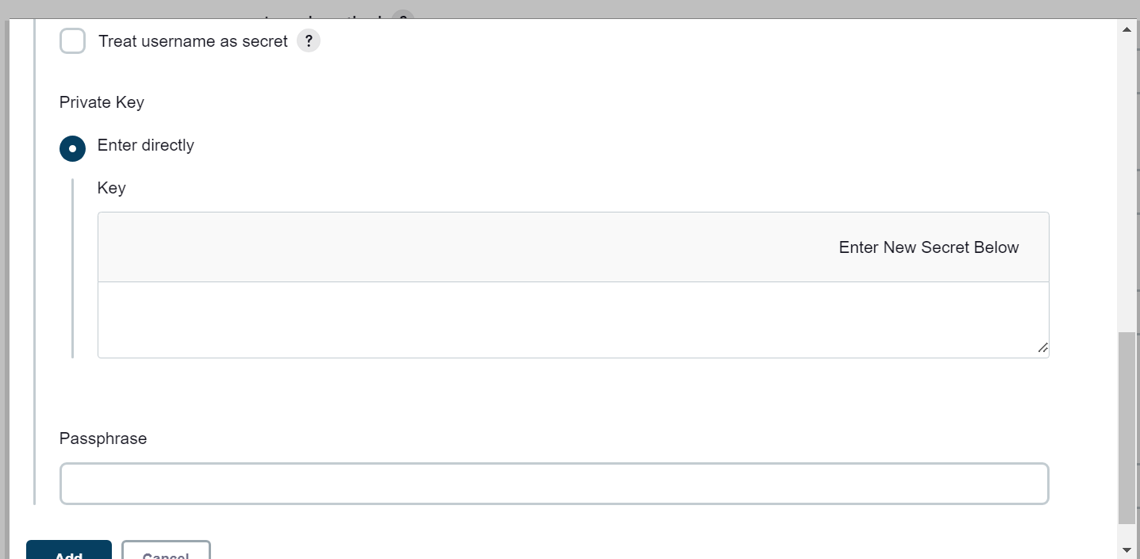

**Ex pipeline code:**

pipeline{

agent **{label 'dev123'} -----> what we give in node setting**

stages{

stage('gitcheckout'){

steps{

git credentialsId: 'path', url: 'https://github.com/kanchana08/Dockerfile_python.git'

}

}

}

}

----------------------------------------------------------------------------------------------

**If we face in any issues we can follow this also**

[] Follow same as above till to copy ssh private key to slave

Don’t do [] ssh jenkins@serverB ip connection

In jenkins select Host Key Verification Strategy in that select manually trusted key verification strategy select click

